**FUNCTIONS.**

**Scenario 1:** Calculate the age of customers for eligibility checks.

* + Question: Write a function CalculateAge that takes a customer's date of birth as input and returns their age in years.

**SOLUTION:**

**Query:**

create or replace function CalculateAge(c_dob in customers.dob%type)

return number

is

age number;

begin

    age:=months_between(sysdate,c_dob)/12;

    dbms_output.put_line('AGE CALCULATED SUCCESSFULLY...');

    return age;

end;

**Output:**

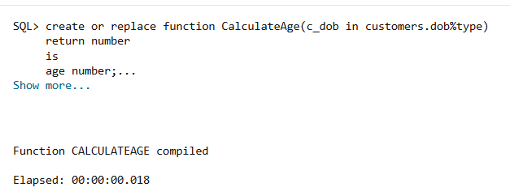

**Query:**

declare

age number;

c_dob customers.dob%type;

begin

    select dob into c_dob from customers where customerid=1;

    age:=CalculateAge(c_dob);

    dbms_output.put_line('AGE OF CUSTOMER WITH DATE OF BIRTH: '||c_dob||' is: '||floor(age));

end;

**Output:**

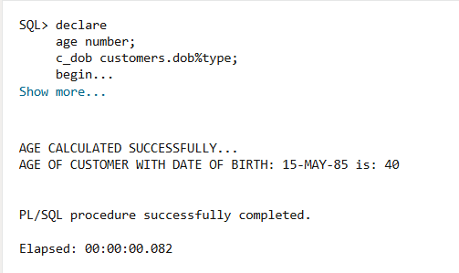

**Scenario 2:** The bank needs to compute the monthly installment for a loan.

* + Question: Write a function CalculateMonthlyInstallment that takes the loan amount, interest rate, and loan duration in years as input and returns the monthly installment amount.

**SOLUTION:**

**Query:**

create or replace function CalculateMonthlyInstallment(loan_amount in loans.loanamount%type,l_interest in loans.interestrate%type,l_year in number)

return number

as

monthly_installment number;

monthly_rate number;

n_months number;

begin

    monthly_rate:=l_interest/12/100;

    n_months:=l_year*12;

    monthly_installment:=loan_amount*monthly_rate*POWER((1+monthly_rate),n_months)/(POWER((1+monthly_rate),n_months)-1);

    return monthly_installment;

end;

**Output:**

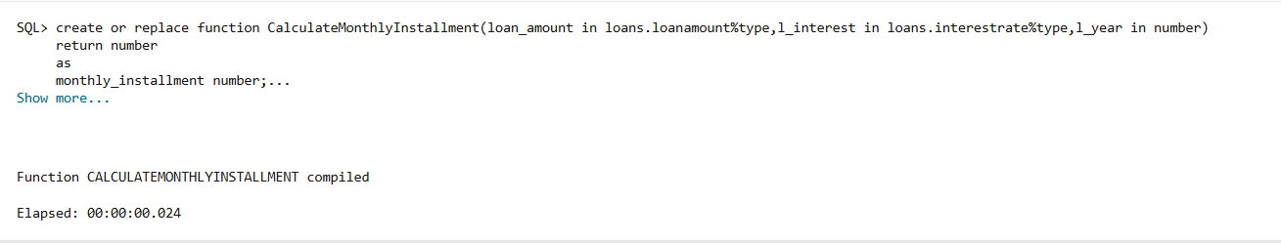

**Query:**

declare

monthly_installment number;

begin

    monthly_installment:=CalculateMonthlyInstallment(50000,6.5,3);

    dbms_output.put_line('MONTHLY INSTALLMENT WITH LOAN AMOUNT: 50000, INTEREST RATE: 6.5% AND 3 YEARS IS: '||round(monthly_installment,2));

end;

**Output:**

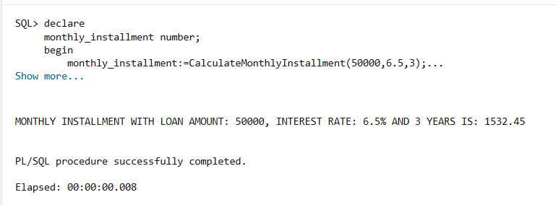

**Scenario 3:** Check if a customer has sufficient balance before making a transaction.

* + Question: Write a function HasSufficientBalance that takes an account ID and an amount as input and returns a boolean indicating whether the account has at least the specified amount.

SOLUTION:

Query: select accountid,balance from accounts where accountid=1 or accountid=103;

Output:

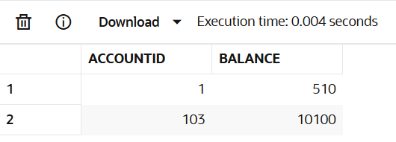

Query:

create or replace function HasSufficientBalance(a_id in accounts.accountid%type,amount number)

return boolean

as

issufficient Boolean;

a_balance number;

begin

    select balance into a_balance from accounts where accountid=a_id;

    if a_balance>=amount then

    issufficient:=true;

    else

    issufficient:=false;

    end if;

    return issufficient;

end;

Output:

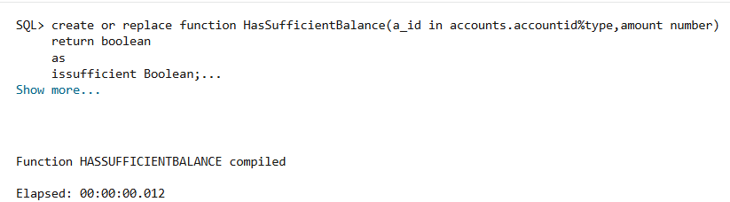

Query:

declare

issufficient Boolean;

begin

    issufficient:=HasSufficientBalance(1,1000);

    IF issufficient THEN

        dbms_output.put_line('ACCOUNTID: 1 HAS SUFFICIENT BALANCE');

    ELSE

        dbms_output.put_line('ACCOUNTID: 1 DOES NOT HAVE SUFFICIENT BALANCE');

    END IF;

    issufficient:=HasSufficientBalance(103,10000);

    IF issufficient THEN

        dbms_output.put_line('ACCOUNTID: 103 HAS SUFFICIENT BALANCE');

    ELSE

        dbms_output.put_line('ACCOUNTID: 103 DOES NOT HAVE SUFFICIENT BALANCE');

    END IF;

end;

Output:

